# Prerequisites

1. Talaria TWO SDK
2. PC with Windows 10 or higher

# Prerequisites for Building the Application using VS Code

## Node.js Installation

Node.js is an open-source java script run-time environment.

Download the Windows Installer (.msi) from the Node.js download page and install it with the administrative rights: <https://nodejs.org/en/>.

Figure 6: Node.js installation

Installation results in a folder similar to: C:\Program Files\nodejs and is added to the system path since it includes the node.exe binary.

## NPM Installation

NPM (Node Package Manager) is the package manager for the Node JavaScript platform. It installs the modules and organizes them so that the node.js can locate the modules. To install NPM, execute the following steps:

1. Launch the Node command prompt.

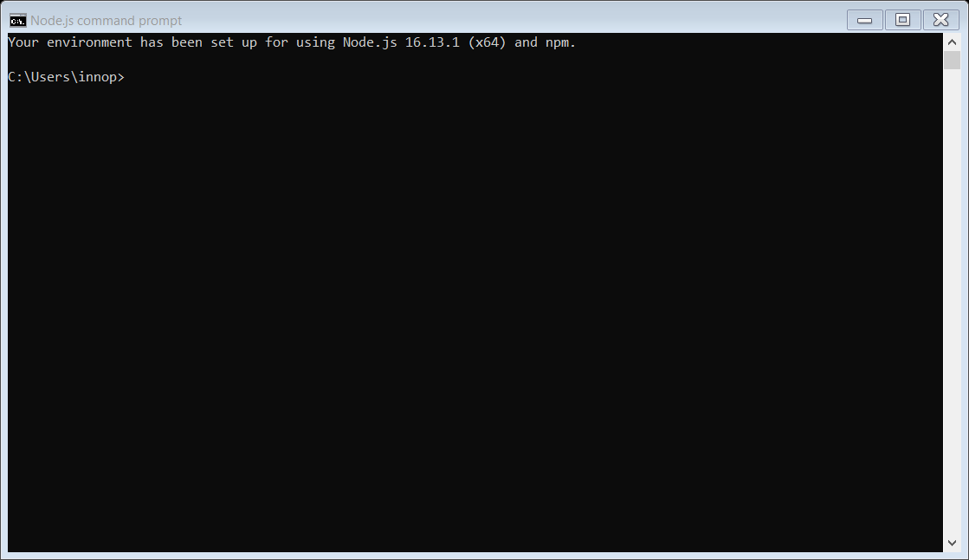

Figure 7: Node command prompt

1. To install the latest version of the NPM through node.js command line, execute the following command:

|  |
| --- |
| npm install --global npm@latest |

Figure 8: NPM latest version installation

## XPM Installation

XPM is the xPack Project Manager. XPM is mainly intended to manage projects during development and build configurations to run actions associated with various build steps.

To install the latest version of XPM through node.js command line, execute the following command:

|  |
| --- |
| npm install --global xpm@latest |



Figure 9: XPM installation

## Windows-Build-Tools Installation

To build projects on Windows, it is necessary to install the make extension (make.exe), which is available from the xPack Windows Build Tools. Running build on Windows requires tools which Microsoft does not include in the base distribution and hence needs to be installed separately.

To install the windows-build-tools through node.js command line , execute the following command:

|  |
| --- |
| xpm install --global @xpack-dev-tools/windows-build-tools@4.3.0-1.1 |

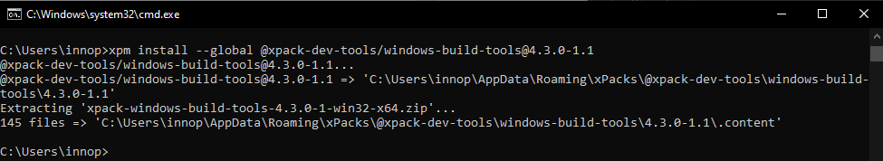

Figure 10: Windows-build-tools installation

## Arm Tool Chain Installation

This toolchain contains integrated and validated packages featuring the compiler, libraries, and other tools necessary for software development. To build ARM projects, an ARM toolchain xPack GNU ARM Embedded GCC is required.

To install the latest version of the ARM tool chain, execute the following command:

|  |
| --- |
| xpm install @xpack-dev-tools/arm-none-eabi-gcc@11.2.1-1.1.1 |

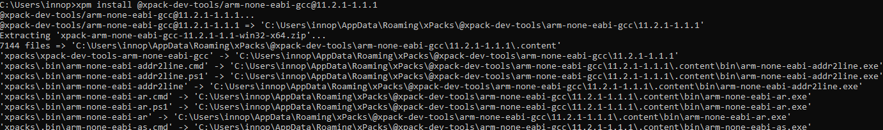

Figure 11: ARM tool chain installation

## OpenOCD Installation

OpenOCD is used for on-chip debugging. In a terminal window, execute the following command to install OpenOCD (For example: version 0.10.0):

|  |
| --- |
| xpm install --global @xpack-dev-tools/openocd@0.10.0-13.1 |

Figure 12: OpenOCD installation

All xPacks are installed in a central folder similar to the one in the following location: C:\Users\<User name>\AppData\Roaming.

Ensure to check the XPM output for the actual location.